**RESTORING DIVISION USING C**

**AIM:**

To write a C program to implement restoring using C.  
  
  
  
  
  
**ALGORITHM:**  
  
  
1)      Store the remainder when the number is divided by 8 in an array.  
  
  
2)      Divide the number by 8 now  
  
  
3)      Repeat the above two steps until the number is not equal to 0.  
  
  
4)      Print the array in reverse order now.

**PROGRAM:**

#include<stdlib.h>

#include<stdio.h>

int acum[100]={0} ;

void add(int acum[],int b[],int n);

int q[100],b[100];

int main()

{

int x,y;

printf("Enter two Number:");

scanf("%d%d",&x,&y);

int i=0;

while(x>0||y>0)

{

if(x>0)

{

q[i]=x%2;

x=x/2;

}

else

{

q[i]=0;

}

if(y>0)

{

b[i]=y%2;

y=y/2;

}

else

{

b[i]=0;

}

i++;

}

int n=i;

int bc[50];

printf("\n");

for(i=0;i<n;i++)

{

if(b[i]==0)

{

bc[i]=1;

}

else

{

bc[i]=0;

}

}

bc[n]=1;

for(i=0;i<=n;i++)

{

if(bc[i]==0)

{

bc[i]=1;

i=n+2;

}

else

{

bc[i]=0;

}

}

int l;

b[n]=0;

int k=n;

int n1=n+n-1;

int j,mi=n-1;

for(i=n;i!=0;i--)

{

for(j=n;j>0;j--)

{

acum[j]=acum[j-1];

}

acum[0]=q[n-1];

for(j=n-1;j>0;j--)

{

q[j]=q[j-1];

}

add(acum,bc,n+1);

if(acum[n]==1)

{

q[0]=0;

add(acum,b,n+1);

}

else

{

q[0]=1;

}

}

printf("\nQuoient : ");

for(l=n-1;l>=0;l--)

{

printf("%d",q[l]);

}

printf("\nRemainder :");

for( l=n;l>=0;l--)

{

printf("%d",acum[l]);

}

return 0;

}

void add(int acum[],int bo[],int n)

{

int i=0,temp=0,sum=0;

for(i=0;i<n;i++)

{

sum=0;

sum=acum[i]+bo[i]+temp;

if(sum==0)

{

acum[i]=0;

temp=0;

}

else if (sum==2)

{

acum[i]=0;

temp=1;

}

else if(sum==1)

{

acum[i]=1;

temp=0;

}

else if(sum==3)

{

acum[i]=1;

temp=1;

}

}

}

**INPUT & OUTPUT:**

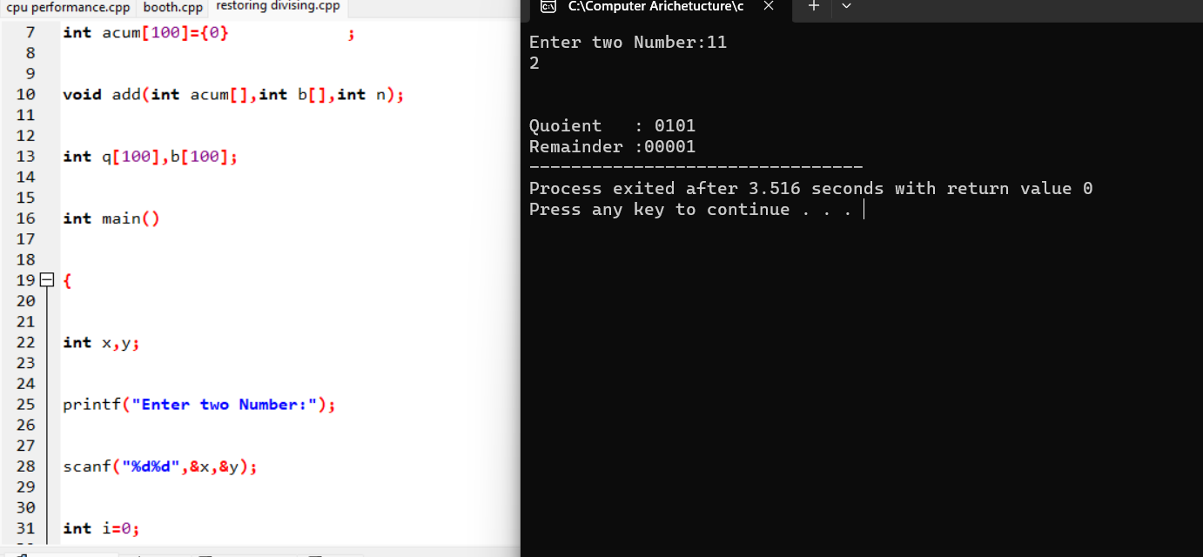

**RESULT:**

Thus we can write the program for Restoring division in DEV C++.